CS401 MPP Midterm

Name:__________________________ StudentId:___________________________

|  |  |  |  |  |
| --- | --- | --- | --- | --- |
| **Part I, 1-7**  **(21)** | **Part II, 1-7**  **(35)** | **Part III, 1**  **(10)** | **Part III, 2**  **(10)** | **Part IV SCI**  **(3)** |
|  |  |  |  |  |

**Part I: Multiple Choice (3 Points Each)**

1. In the following code, which of the following is correct regarding the relationship between Employer and Gardener? Circle one letter.
2. There is a dependency from Employer to Gardener
3. There is a one-way association from Employer to Gardener
4. There is a two-way association between Employer and Gardener
5. Not possible to determine from the code shown.

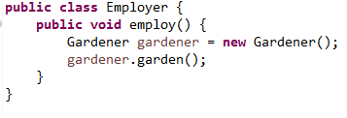

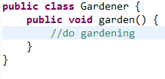

1. Consider the following class diagram:  
   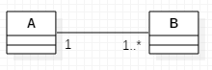  
   Which of the following statements is (are) correct? Circle all that are correct.
   1. Each instance of the class B contains a list of instances of A.
   2. Each instance of the class A contains a list of instances of B.
   3. A is a property of B.
   4. If an instance of A has been created, at least one instance of B has also been created.
   5. After an instance of A has finished creating instances of B (either inside its constructor or inside some other constructing method), the instances become null automatically after A’s constructor or A’s constructing method returns.
2. Which of the following UML diagrams correctly models the relationship between Director and Program? The code for Director and Program is shown below.

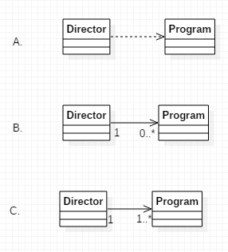

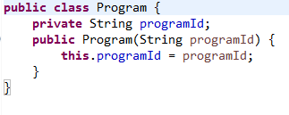

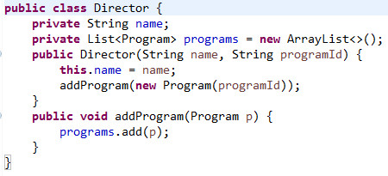

1. When the following code is executed, it prints the areas of each of the geometric figures that have been initialized in the main method.  
   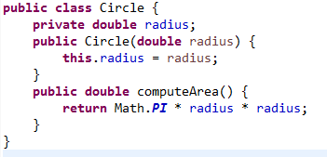

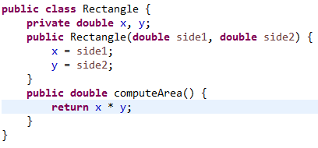  
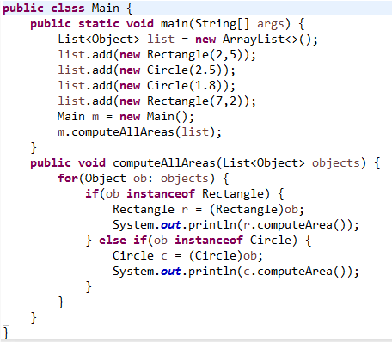

Although the code gives correct outputs, it violates an OO principle. Which of the following OO principles is violated by the structure of this code? Circle only one letter.

* 1. Liskov Substitution Principle
  2. Ripple Effect
  3. Program to the Interface
  4. Open-Closed Principle

1. Determine which of the following classes is NOT immutable. Circle the letters for all that apply.

|  |  |
| --- | --- |
| A. |  |
| B. |  |
| C. |  |

1. The difficulties with the ExtendedHashSet example, discussed in class, exemplify the following (circle *the best answer*). (Code shown below.)
   1. The Ripple Effect
   2. The incompatibility between the OO principles of Encapsulation and Inheritance
   3. A subclass may break because of a change in its superclass
   4. All of the above.
   5. None of the above.

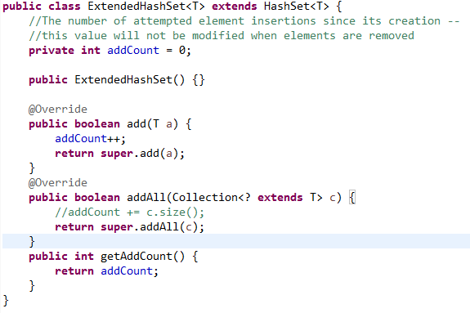

1. What happens when the following code is compiled/run? Select only *one.*  
     
   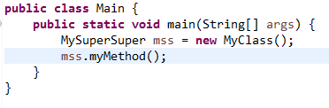

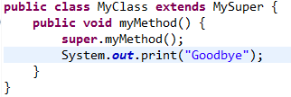

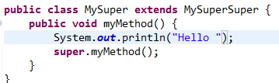

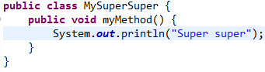

* 1. Compiler error
  2. Runtime exception is thrown
  3. The following is printed to the console:

Hello

Super super

Goodbye

* 1. The following is printed to the console:

Super super

* 1. The following is printed to the console:

Super super

Hello

Goodbye

**Part II: Short Answer (5 Points Each)**

1. Portions of three of the classes in a particular Java application whose UI is coded using JavaFX are shown below. The designer is planning to implement a 1:1 two-way association between the MainStage class and the Controller class. Write code that will guarantee such a relationship between these classes when the MainStage class is instantiated. Write your code directly in the classes provided below. (The Controller class appears on the following page.)

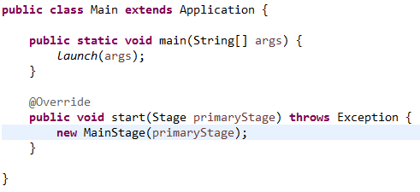

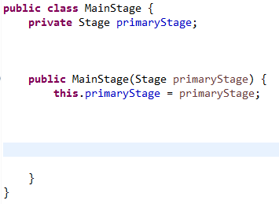

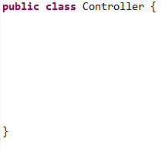

1. A rectangle can be specified by specifying two sides, but it can also be specified by specifying one side and a diagonal.
2. The following code attempts to implement a Rectangle class and provide support for the two ways of constructing a Rectangle. The code does not compile. What is the compiler error? (Write your answer below.)

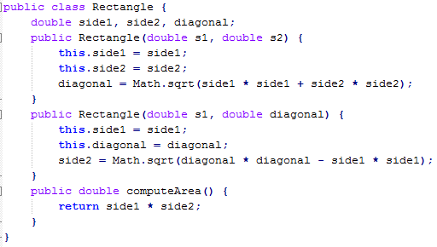  
Your Explanation:

1. In the space provided below, rewrite the code for Rectangle (from Part A) so that it supports the two ways of constructing a rectangle. Use a technique described in the course.

class Rectangle {

}

1. Name two ways of guaranteeing that no user of your class MyClass can create a subclass of MyClass.
2. A Person may *like* other Persons, and may also be *liked by* other Persons. Draw a class diagram showing these relationships. Use one or more associations; each should have a name and appropriate multiplicities. You must indicate clearly whether associations are 1-way or 2-way.
3. In a Windows file system, a directory may contain files and other directories. Represent these concepts with classes Directory and File in a class diagram and show association relationships. You do not need to specify attributes or operations in these classes. Associations should be provided with multiplicities and names. NOTE: If A is a subdirectory of B and B is a subdirectory of C, it is not true that A is a subdirectory of C.

1. Explain the difference between *analysis* and *design* in the software development lifecycle.

1. What is the Evolving API Problem?

**Part III: Design (10 Points Each)**

The game of chess in the West is a two-person game involving a checkered 8 x 8 chessboard containing 64 squares, with alternating colors black and white, and a set of 32 pieces – 16 black pieces for one player, 16 white pieces for the other player. The starting position of a game of chess is shown below.

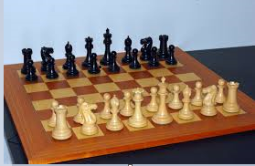

The game proceeds as follows: The white player (called White) moves first by making a legal move with one of his white pieces. The black player (called Black) then makes a legal move with one of his black pieces. Each piece is allowed to move in certain ways, specified by the rules of chess. According to the rules, in certain circumstances, a player may also capture an opponent’s piece. Players continue to take turns making moves until a configuration of the game arises that indicates either a victory for one of the players or a draw (neither player wins).   
  
You have been asked to create a design for an online chess game. The game will display a board with pieces, which will look similar to the image above. There will be two online players, and each player will be represented by a Player object in the game. A Player object stores the user’s name and whether he is White or Black. It also stores the Player’s record of wins, losses, and draws (this record is called the *won-lost record*). The squares on the board are specified using the following grid:

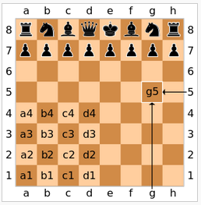

Each piece in the game is represented by a Piece object, which stores its position (using the naming system described above), and which also has a *draw* operation that allows it to draw itself on the displayed Board at its specified position.  
  
During the game, the system maintains a Grid (which is similar to the image shown above), that keeps track of the arrangement and locations on the board of all the pieces in the game.

Each online player uses the naming system described above to submit his/her next. For example, if WHITE has a piece at position **g5** and he wishes to move it forward one square, he would submit to the system the message “**g5** **to** **g6**.”

When a player submits a play to the system (like “**g5** **t**o **g6**”), the system will then pass the current Grid and the requested move to a Verifier to check that the move is legal. If the Verifier accepts the move, the system will update the Grid with the new position, and it will locate the Piece to be moved by reading the first position specified by the user (in this example, position **g5**) and locating this position on the Grid. It will then update Piece’s position in accordance with the user’s specification (in this example, the Piece’s position would be changed to **g6**). The system will then pass the updated Grid to the Board and ask the Board to redraw itself. As part of the process of re-drawing itself, the Board will ask the Pieces to re-draw themselves. (If a Piece is captured, the captured Piece will be told to disappear.)

After the system has completed the move, it passes the Grid to the Verifier, which will determine if the game is over, and declare a winner (if there is one). If the game is declared finished, the system updates both Players’ won-lost records. A “Game Over” message is then displayed.

The two parts of this problem are shown on the following pages.

Notes about the problem:

A. There is no need to model a data access layer or a rules engine in this problem (so don’t do it!).

B. Your sequence diagram should show an actor, a UI class, and a Controller class. Include the UI and Controller classes in your class diagram also.

1. Create a class diagram for this system. Show attributes, operations, and associations (include multiplicities; also include names for associations *if* it is useful to do so).
2. Create a sequence diagram for the following scenario: White makes a move that results in a victory for White. Assume that White’s move is legal and that the Verifier determines that White is the winner after this move is made. Be sure to show activation bars and message numbering. Show parameters in your messages if applicable.

**Part IV: SCI (3 Points)**

Write one or two paragraphs relating a point from the course to a principle from SCI.